Day 8 - 7th june- 113195064 - Bondili Bhavya Charitha

**TASK31:**

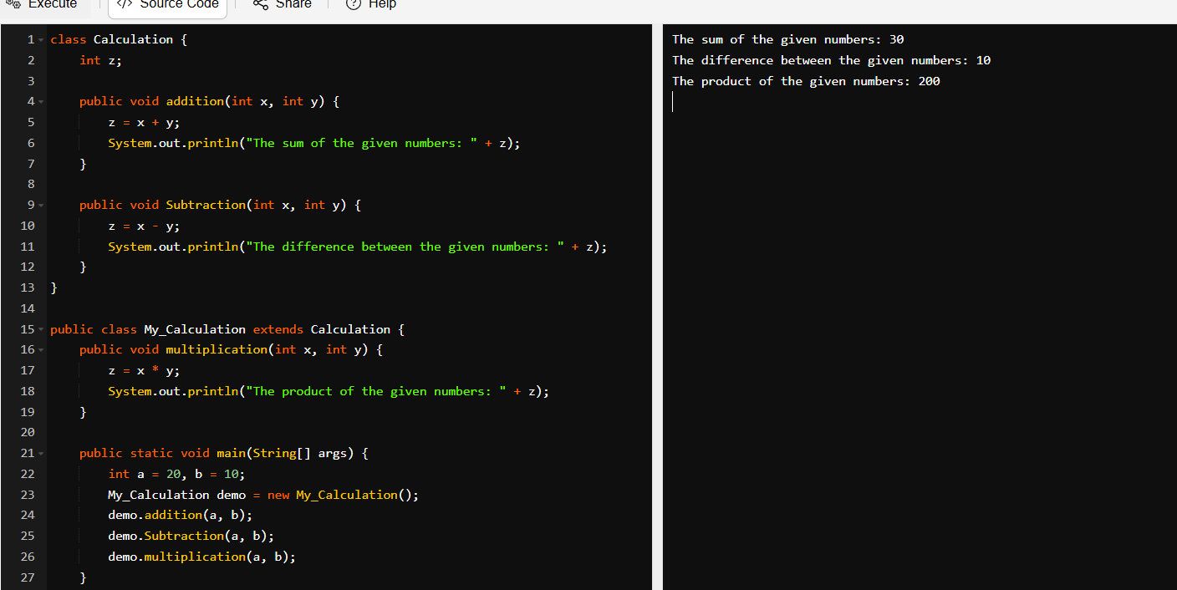

**TASK32:**

No, Java does not support multiple inheritance using classes.

In given code it is class my_calculation extends calculation, clock { }, so it will give error like error: '{' expected.

Corrected code will be:

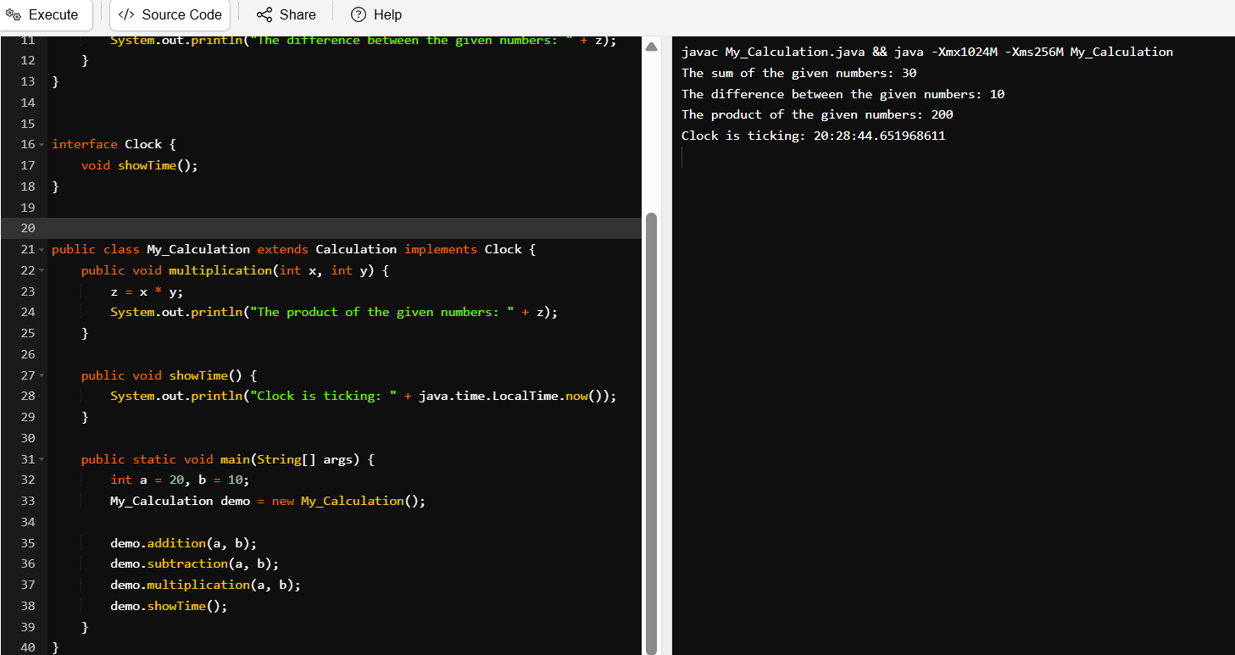

**TASK:33**

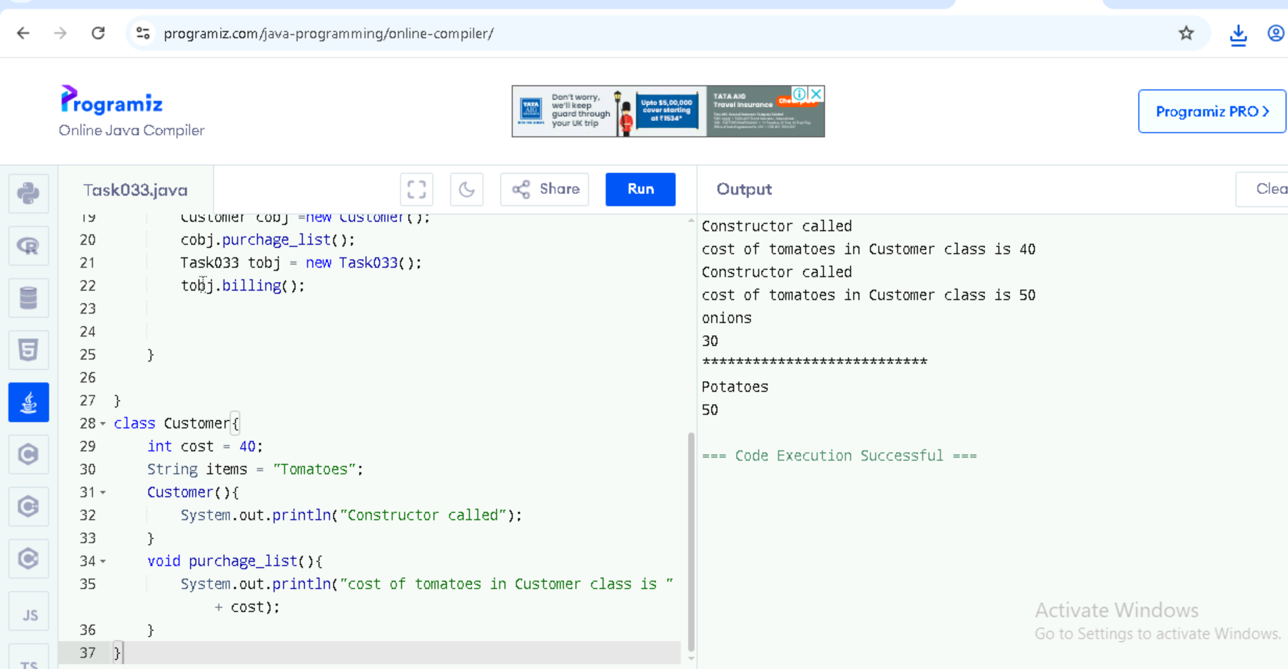

**TASK033_1:**

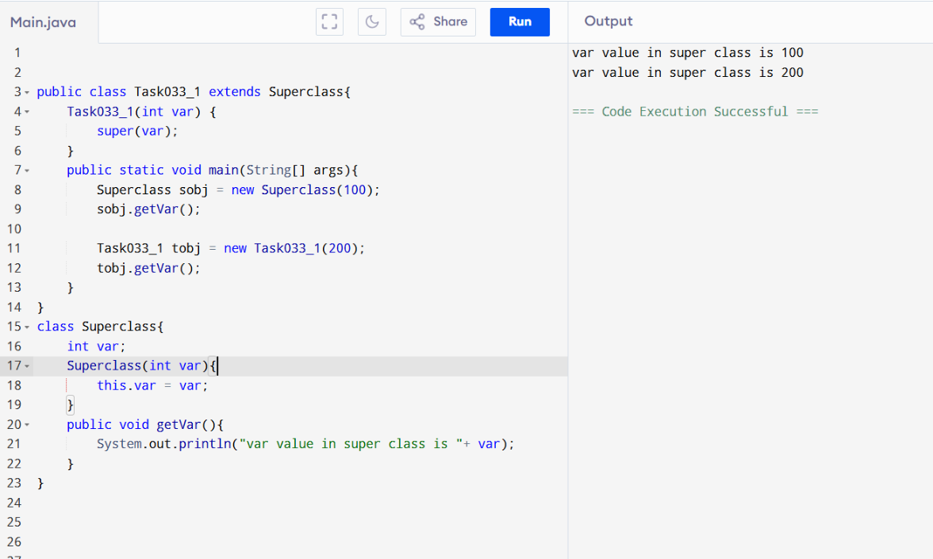

**TASK34:**

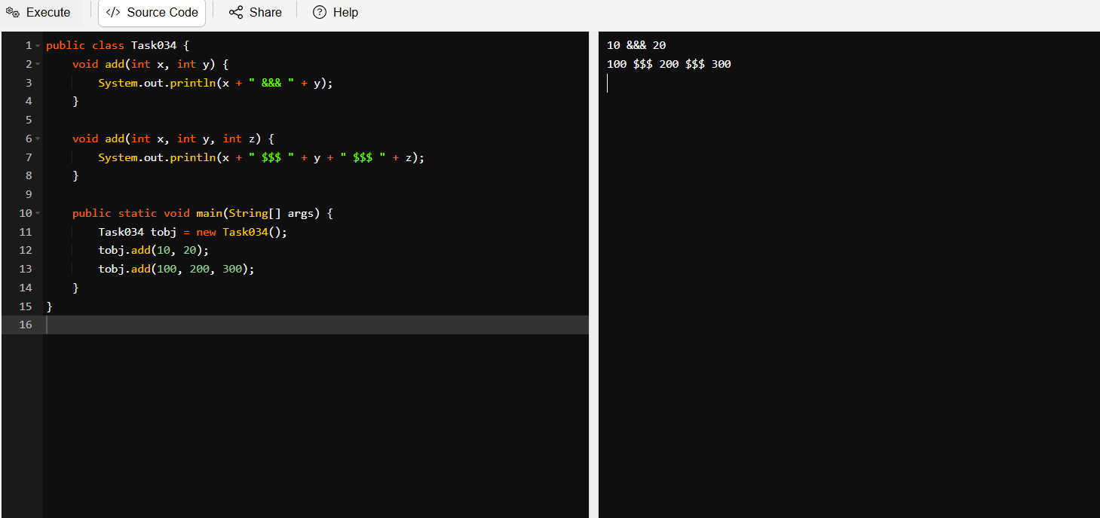

**TASK35:**

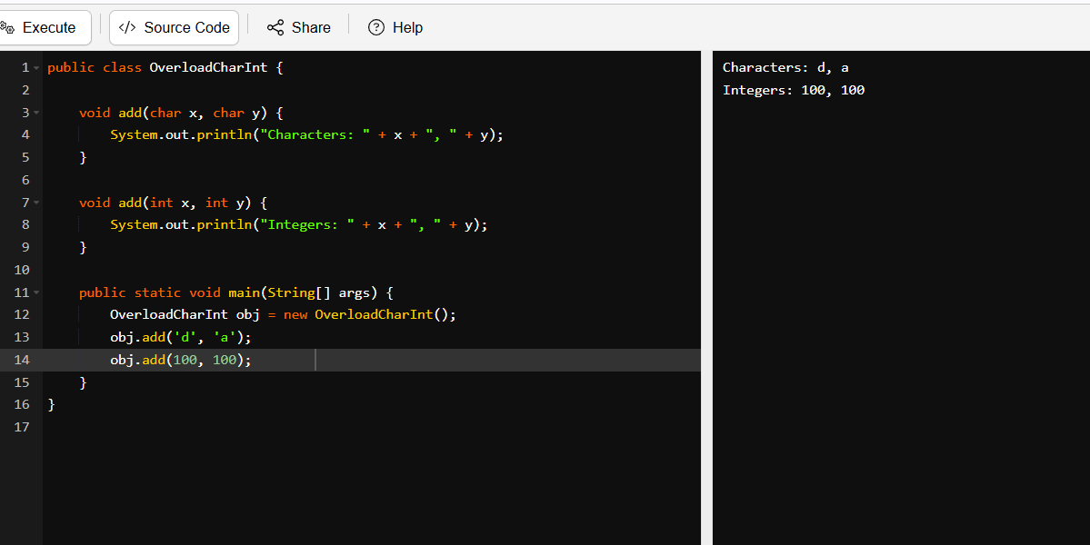

**TASK36:**

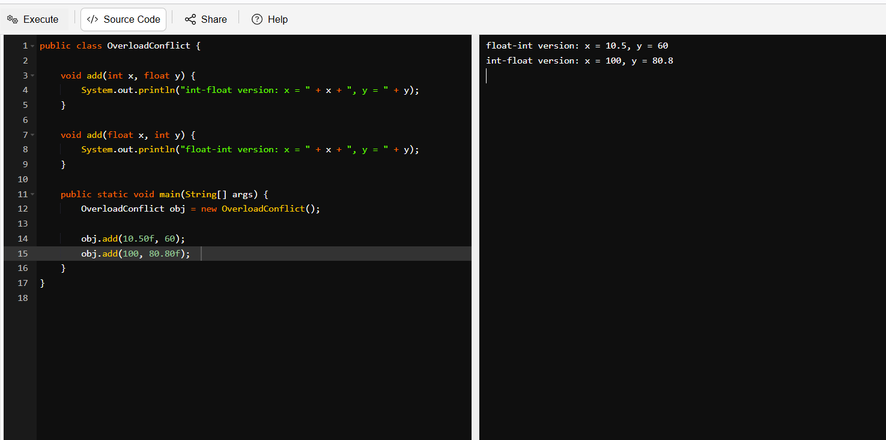

**TASK37:**

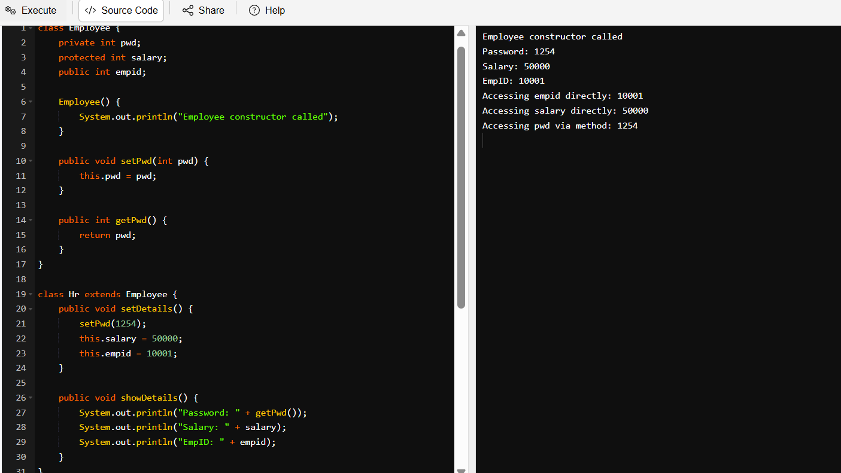

**TASK38:**

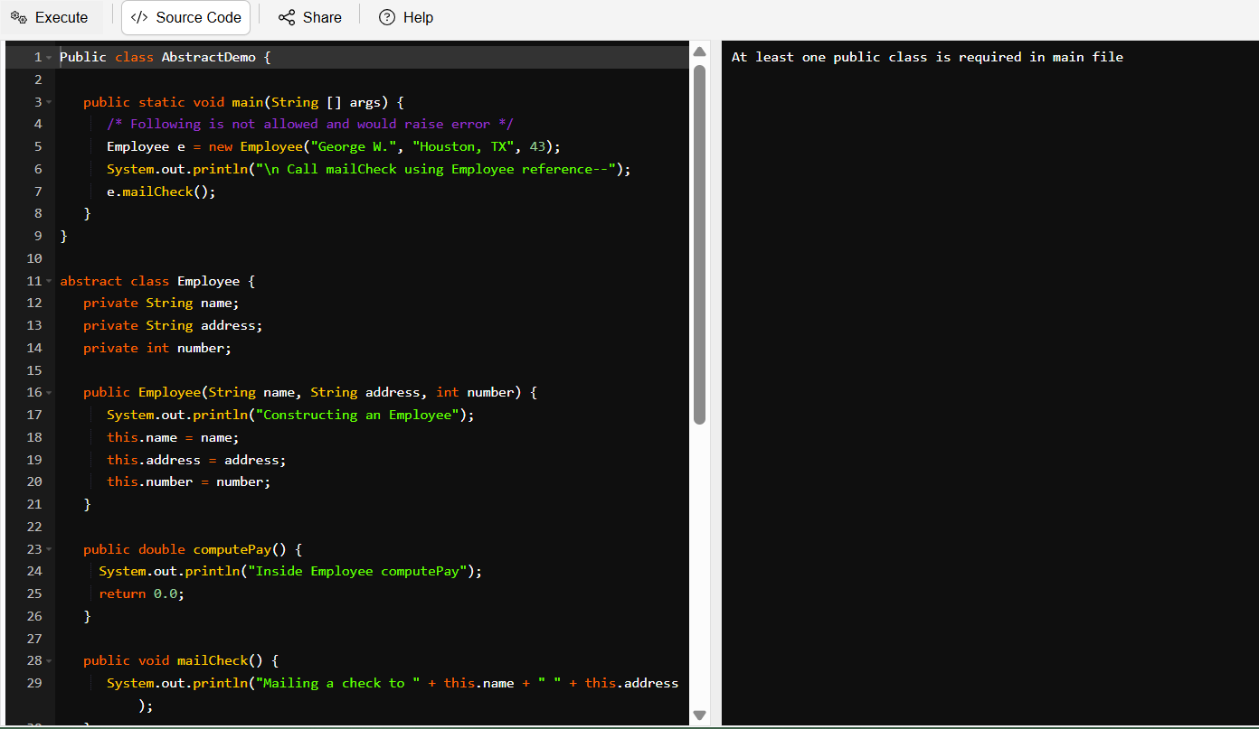

**TASK39:**

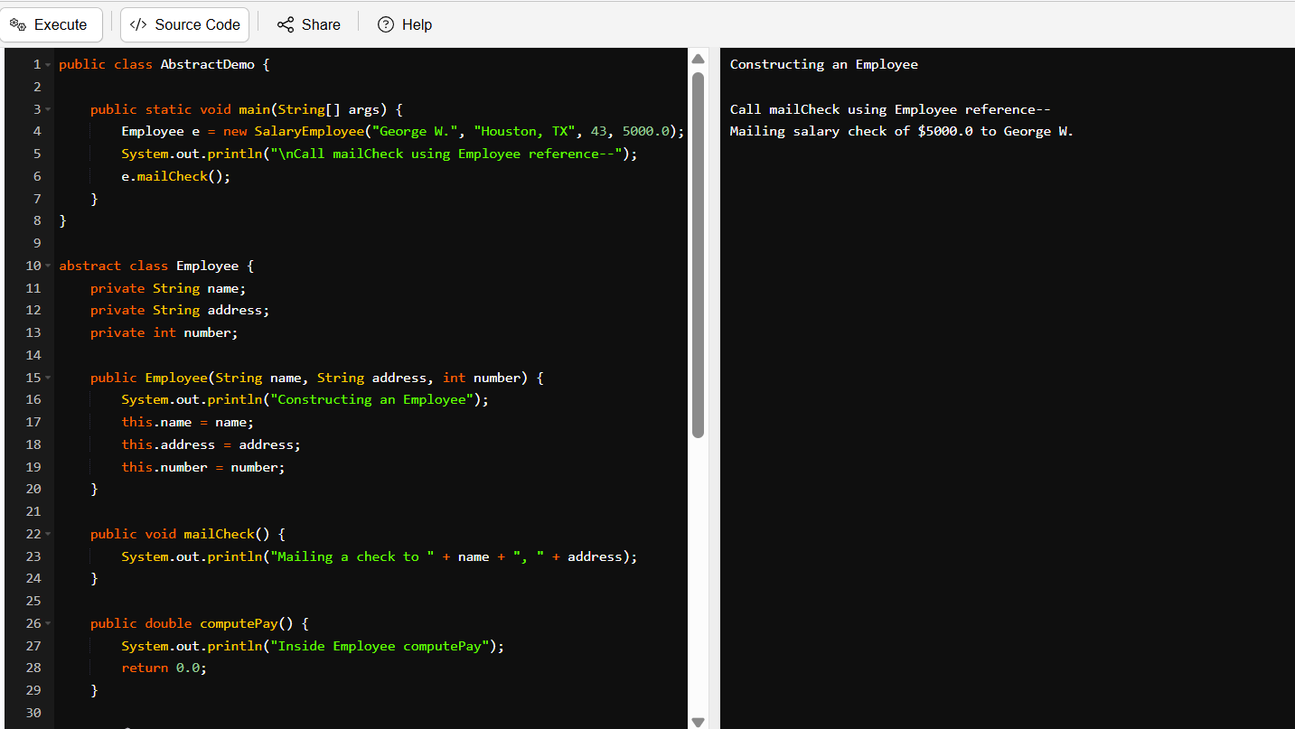

**TASK40:**

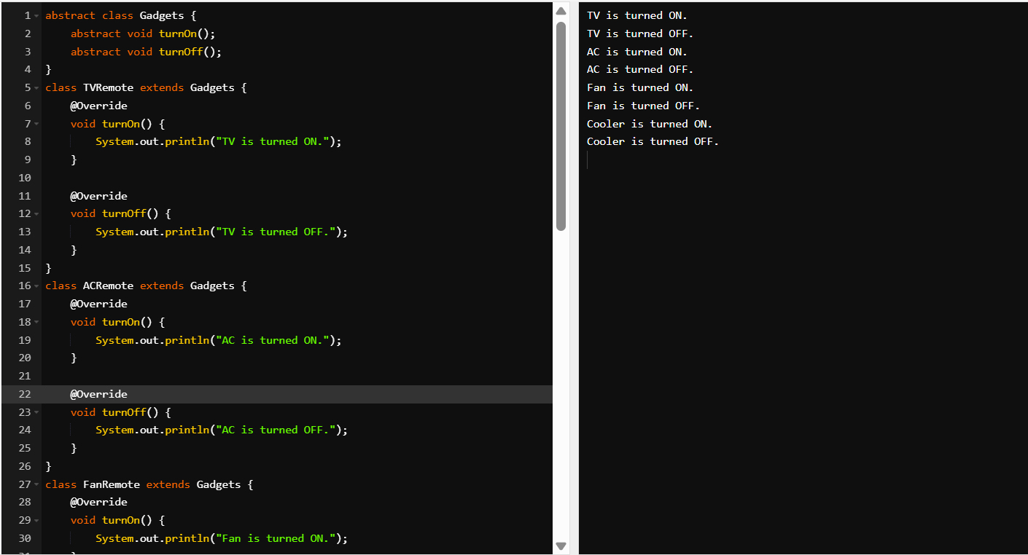

**TASK41:**

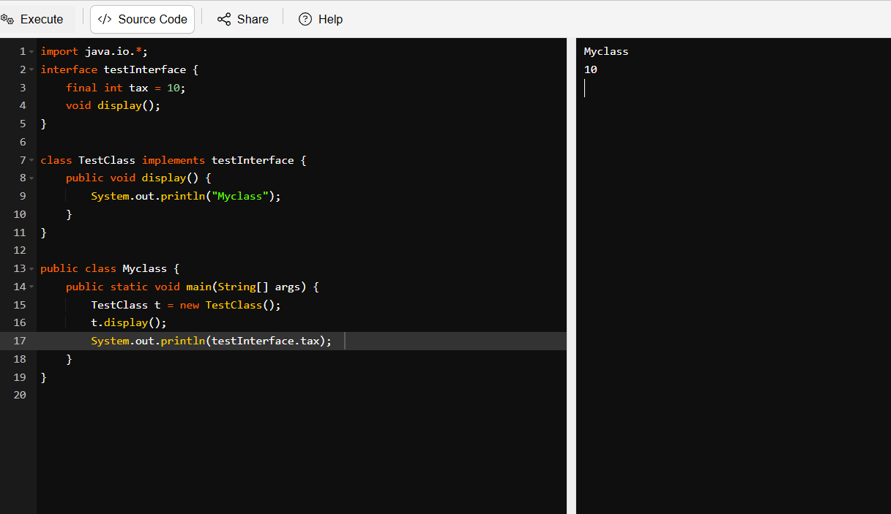

**TASK112:**

